Array’s Problem

1.Reverse an Array

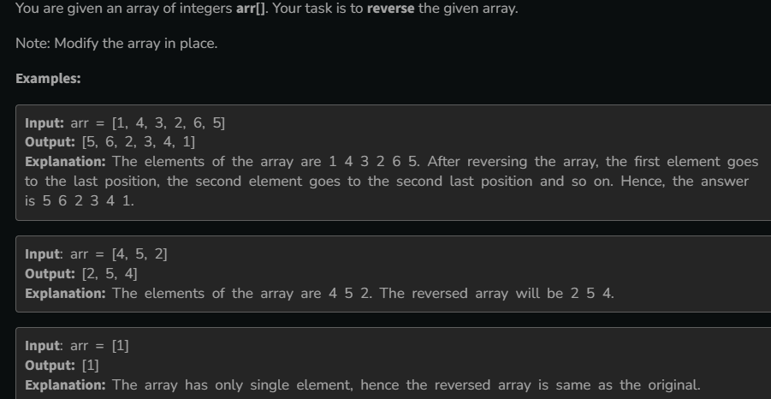

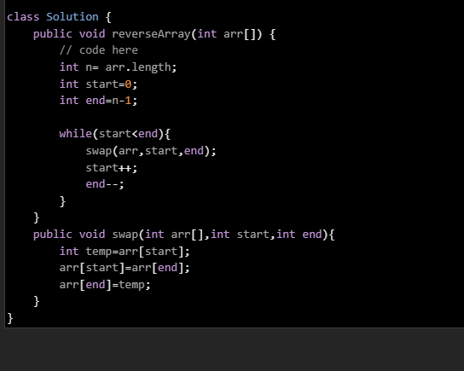

2.Min and max in Array

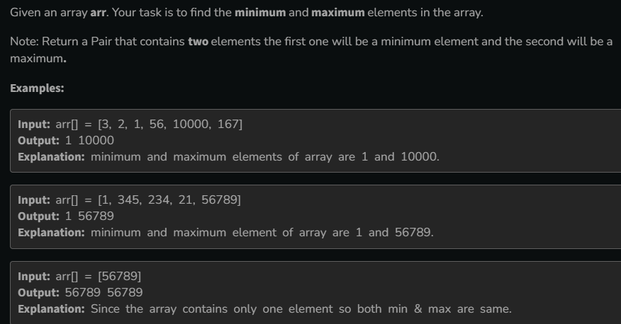

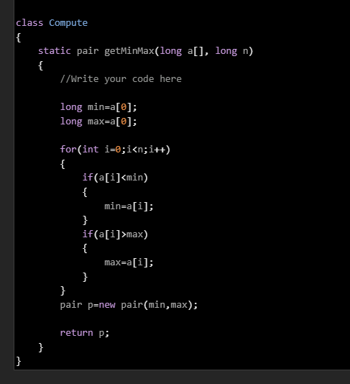

3.Kth Smallest Element

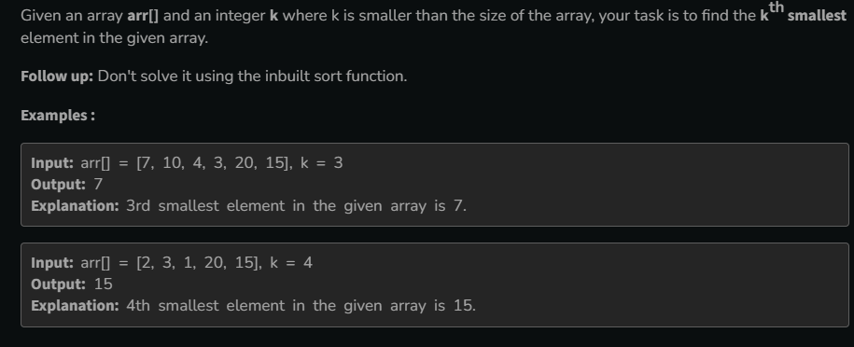

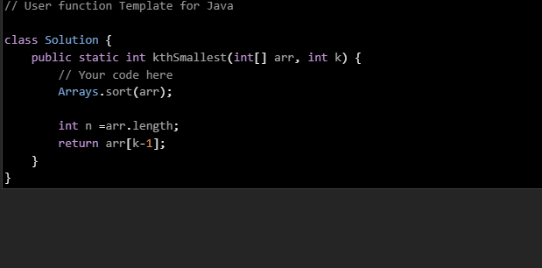

4.Sort 0’s,1’s and 2s

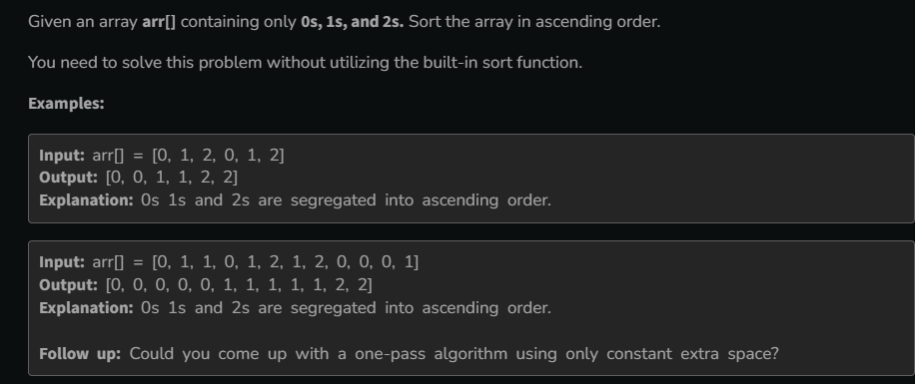

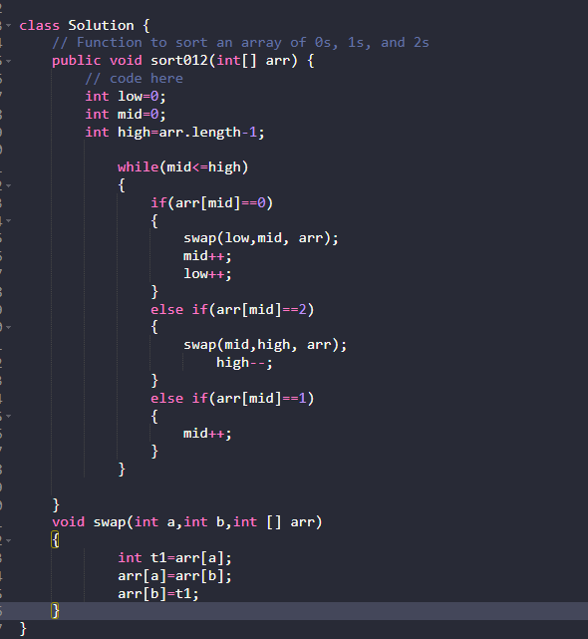

5.Move all Negative element to the End

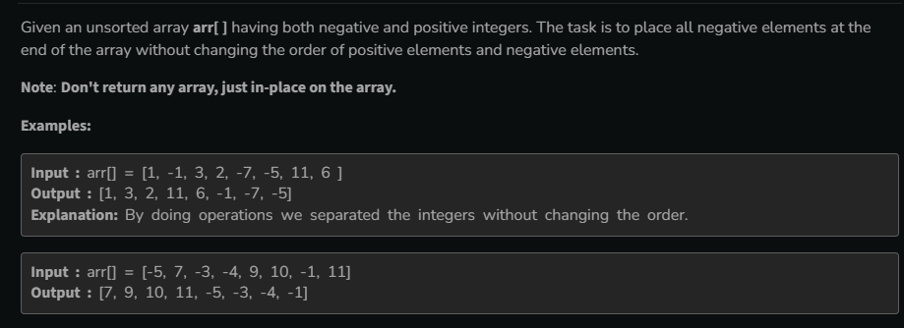

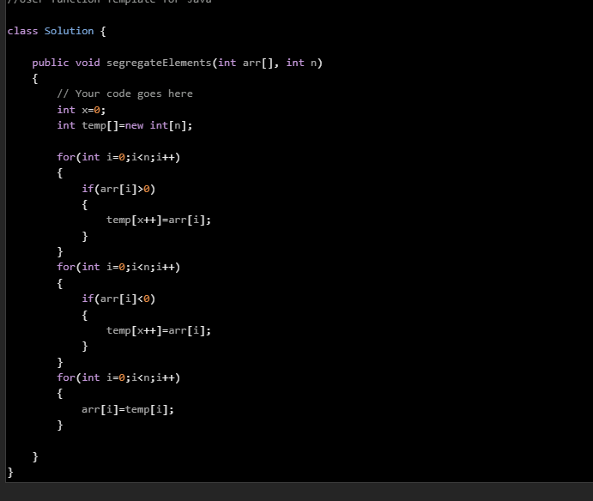

6.Union of array with Duplicates

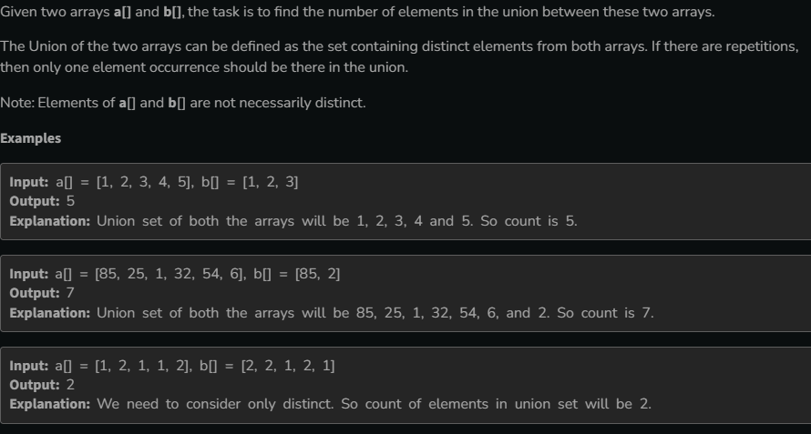

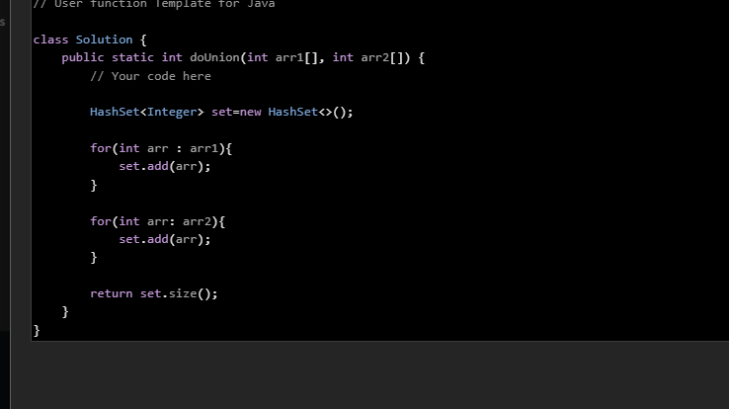

7.Rotate array by one

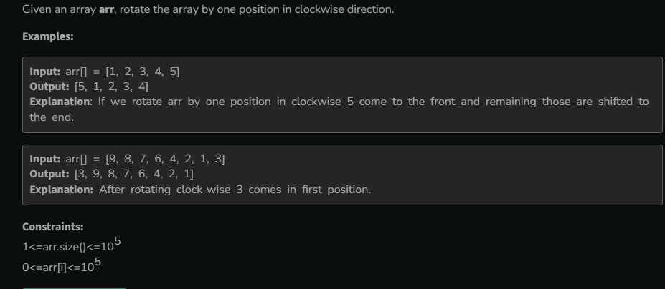

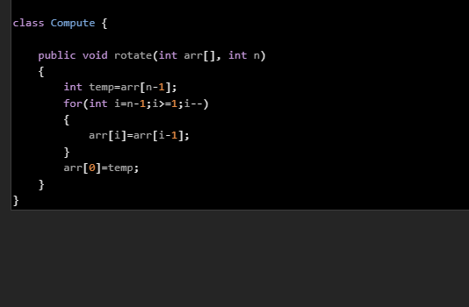

8.Kadane’s Algorithm

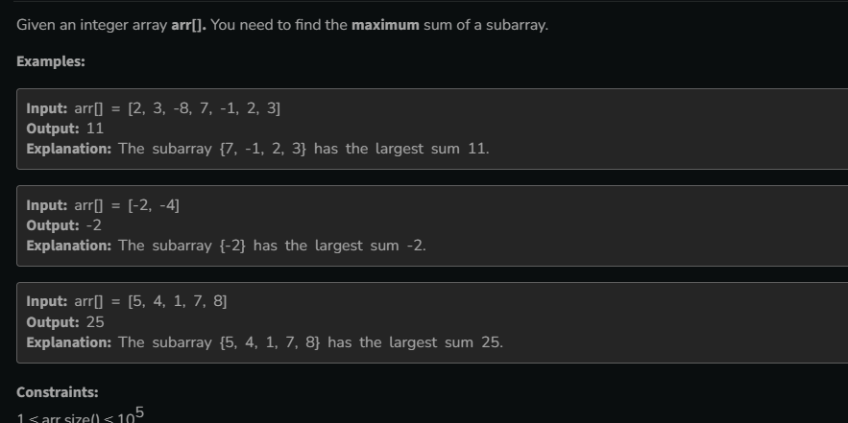

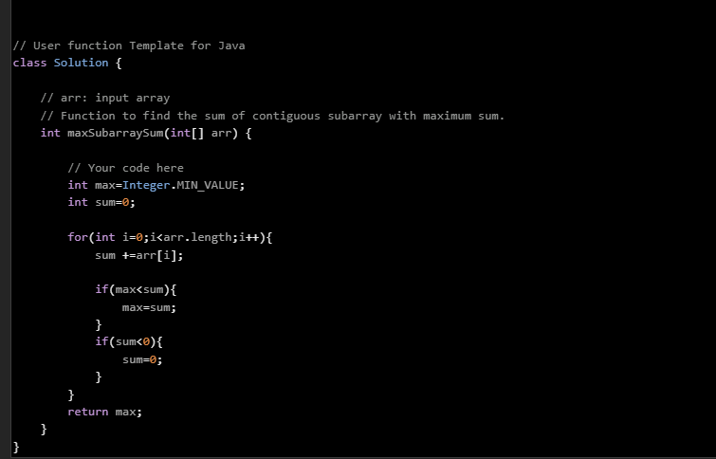

9.Minimise the heights II

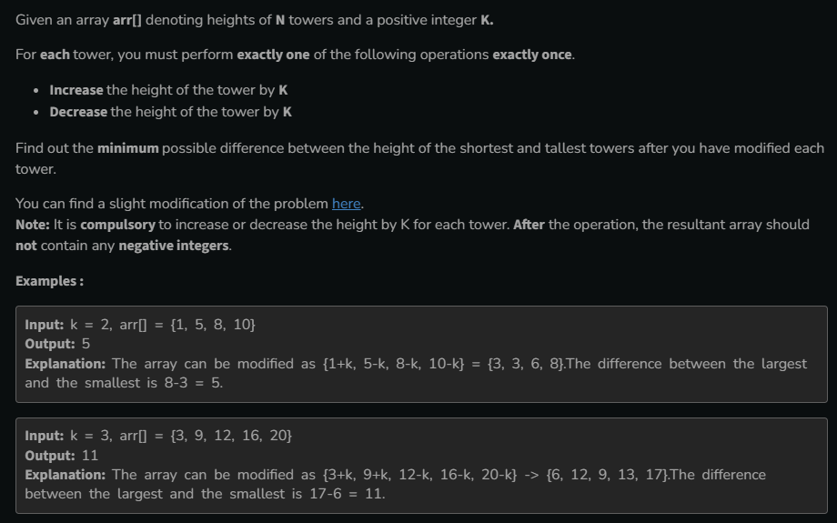

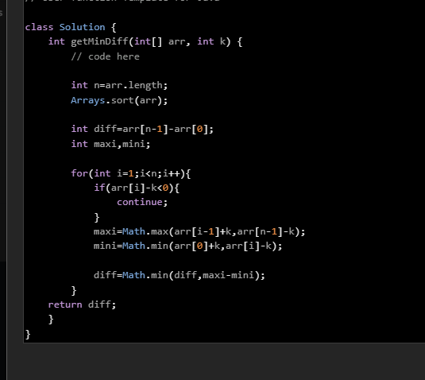

10.Minimum Jumps

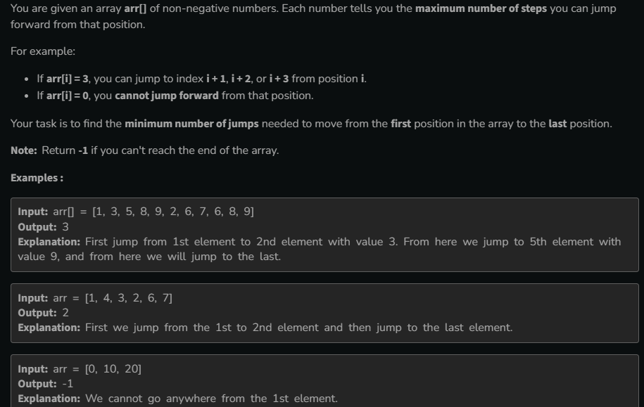

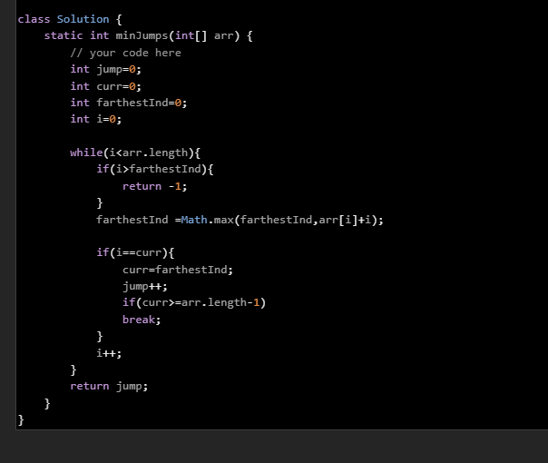

11.Find The Duplicate number

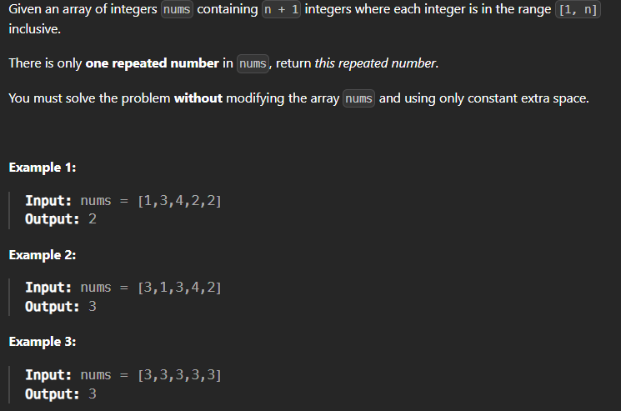

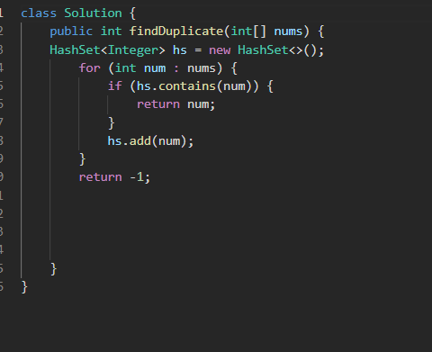

// TC: O(n), SC: O(1)

public int findDuplicate_CyclicSortWay(int[] nums) {

int i = 0;

while (i < nums.length) {

if (nums[i] != nums[nums[i]]) swap(nums, i, nums[i]);

else i++;

}

return nums[0];

}

public void swap(int[] arr, int i, int j) {

int temp = arr[i];

arr[i] = arr[j];

arr[j] = temp;

}

// TC: O(n), SC: O(1)

public int findDuplicate_FloydCycleDetection_AnotherWay(int[] nums) {

if (nums.length == 0) return -1;

int slow = nums[0], fast = nums[nums[0]];

while (slow != fast) {

slow = nums[slow];

fast = nums[nums[fast]];

}

slow = 0;

while (slow != fast) {

slow = nums[slow];

fast = nums[fast];

}

return slow;

}

// TC: O(n), SC: O(1)

public int findDuplicate_FloydCycleDetection(int[] nums) {

int slow = nums[0], fast = nums[0];

do {

slow = nums[slow];

fast = nums[nums[fast]];

} while (slow != fast);

slow = nums[0];

while (slow != fast) {

slow = nums[slow];

fast = nums[fast];

}

return slow;

}

// TC: O(n), SC: O(1)

public int findDuplicate_ModifyInput(int[] nums) {

for (int i = 0; i < nums.length; i++) {

int val = abs(nums[i]);

if (nums[val] < 0) return val;

nums[val] *= -1;

}

return -1;

}

// TC: O(n), SC: O(n)

public int findDuplicate_SetApproach(int[] nums) {

Set<Integer> set = new HashSet<>();

for (int num : nums) {

if (set.contains(num)) return num;

set.add(num);

}

return 0;

}

// TC: O(nlogn), SC: O(1)

public int findDuplicate_SortApproach(int[] nums) {

Arrays.sort(nums);

for (int i = 1; i < nums.length; i++) {

if (nums[i] == nums[i - 1]) return nums[i];

}

return -1;

}

12.Merge Without Extra space

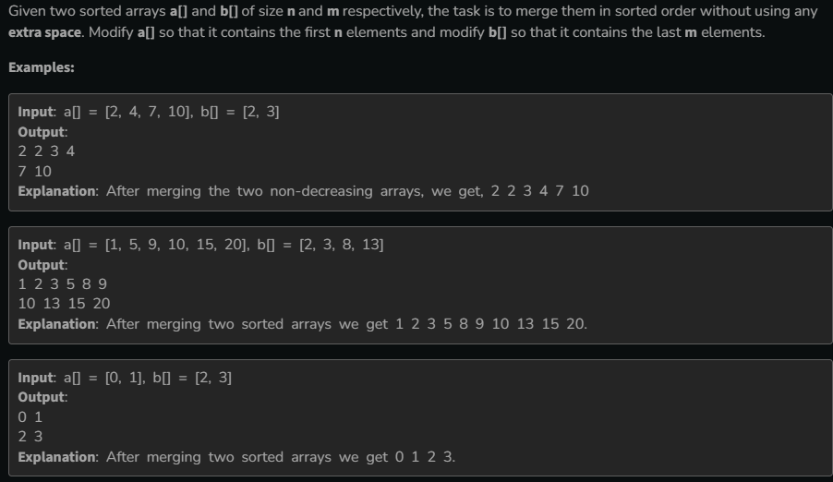

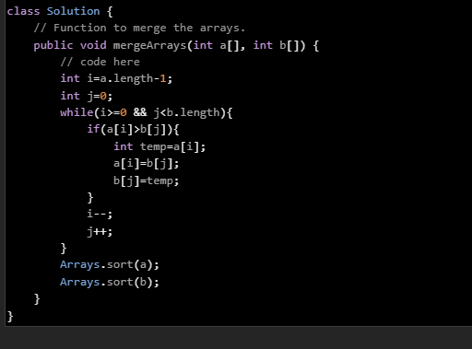

13.Merge Intervals

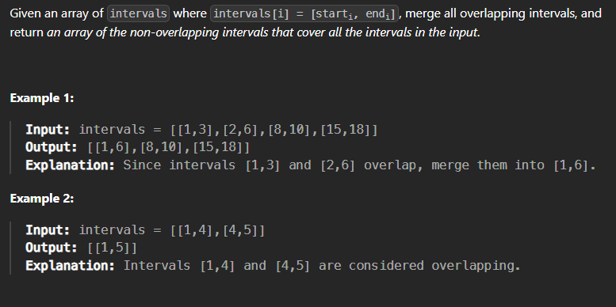

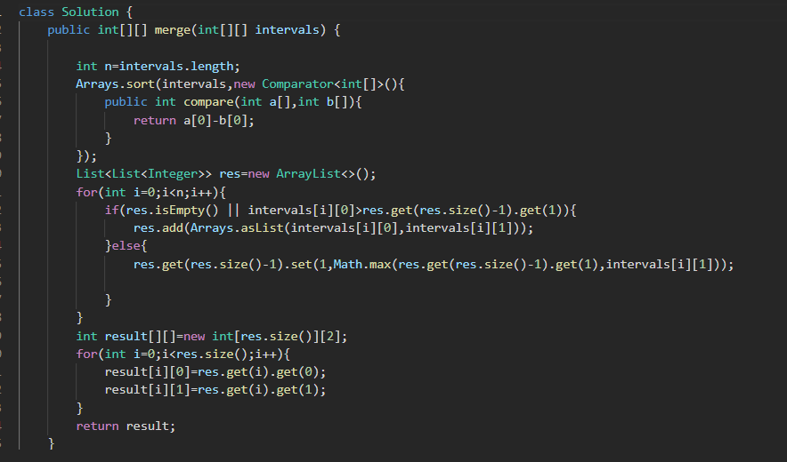

14.Next Permutation

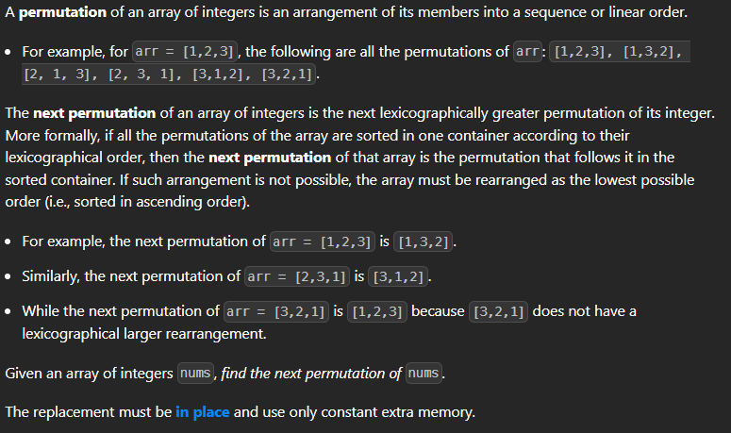

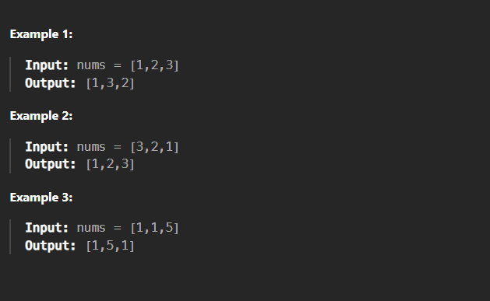

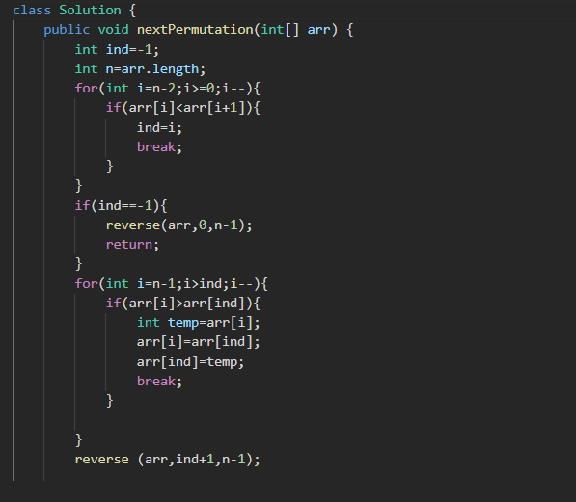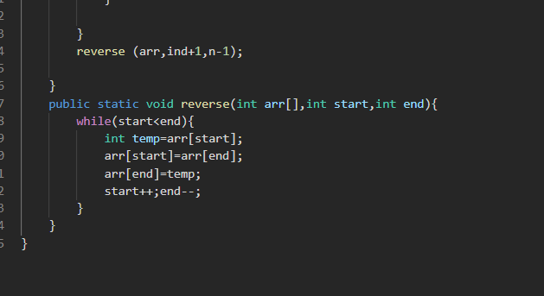

15.Count Inversion

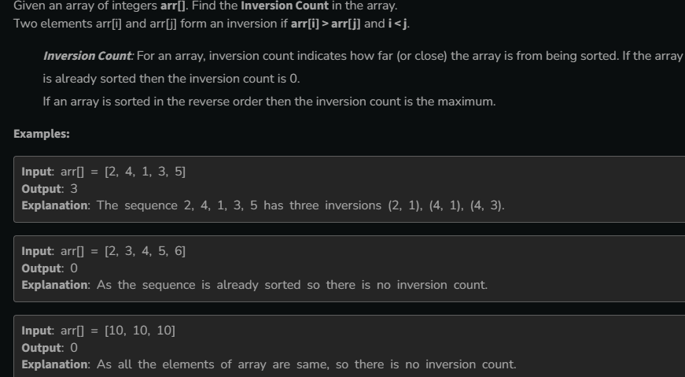

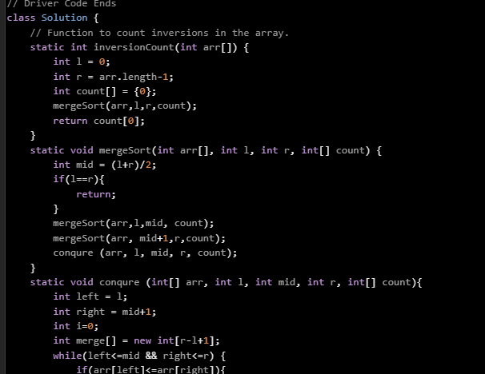

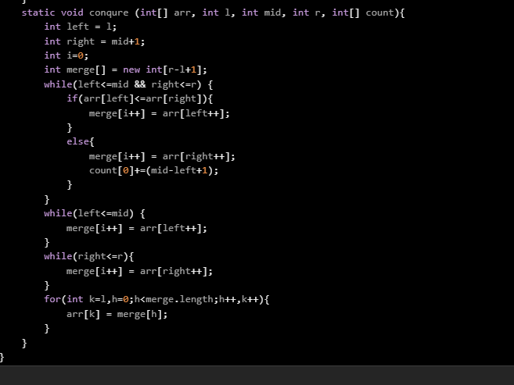

16.Best Time to buy and sell stock

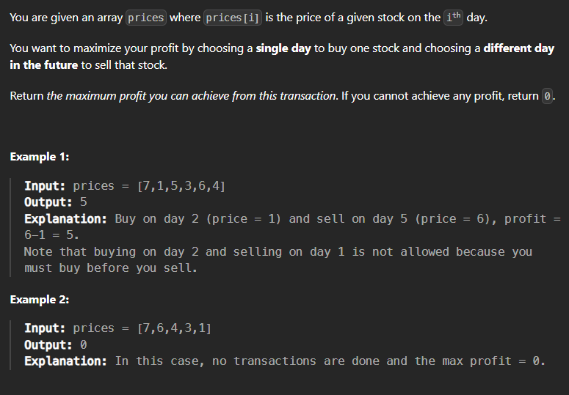

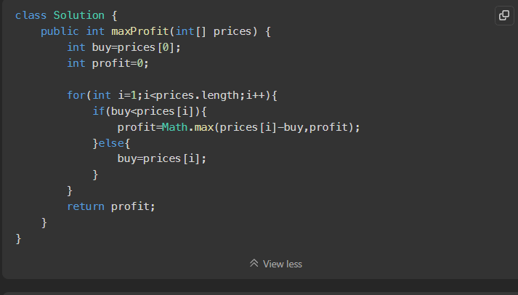

17.Two sum pair with 0 sum

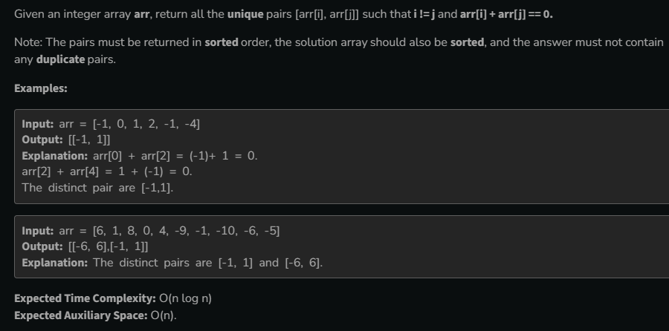

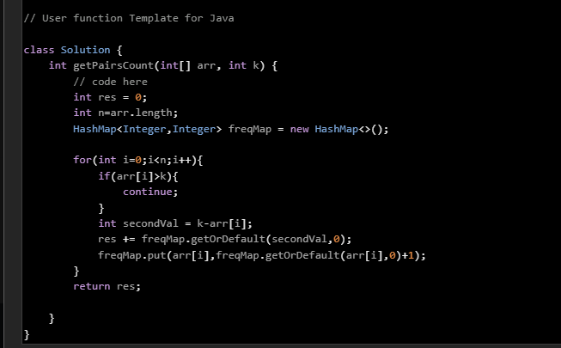

18.Common in 3 sorted array

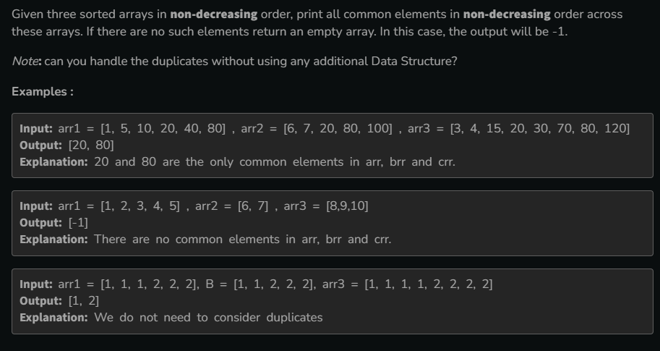

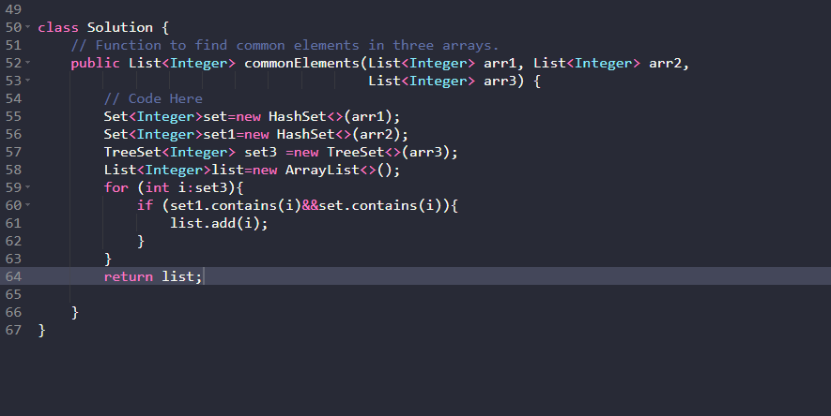

19.Subarray with 0 sum

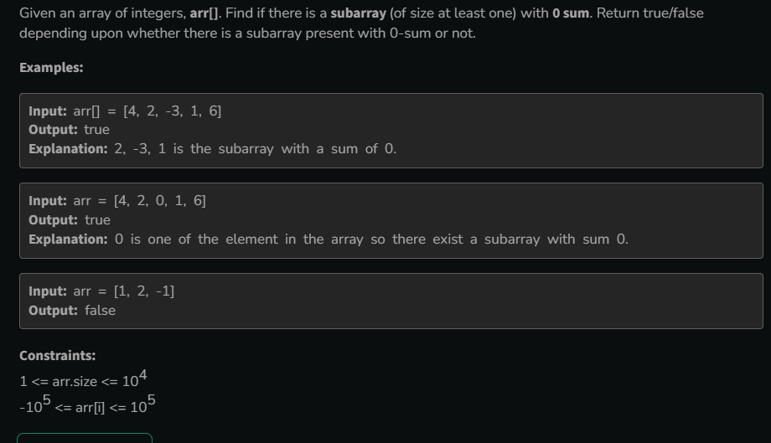

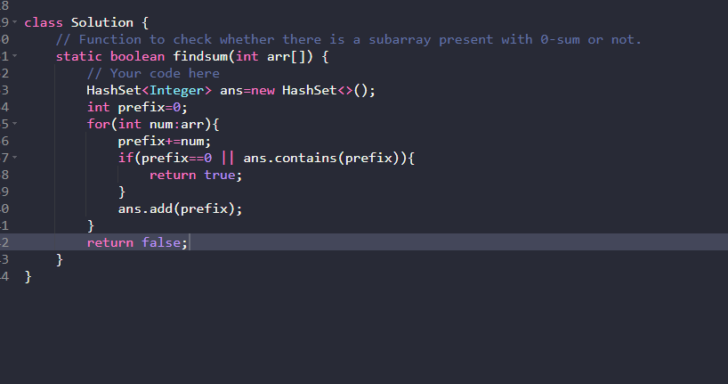

20.Factorial of large number

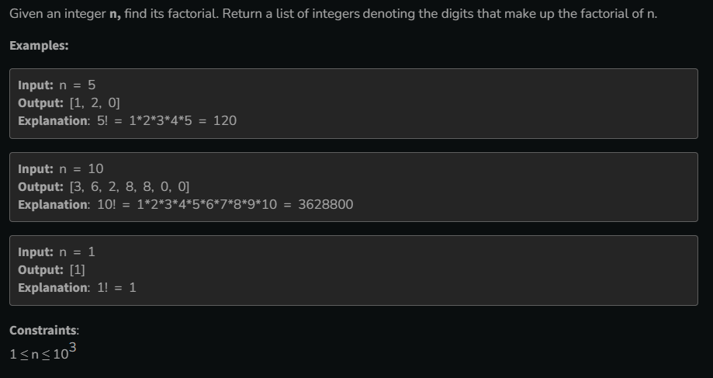

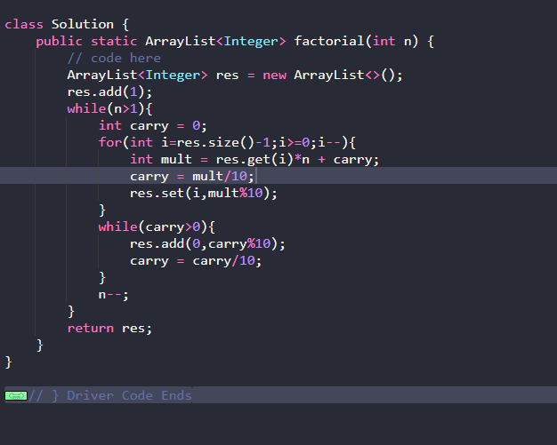

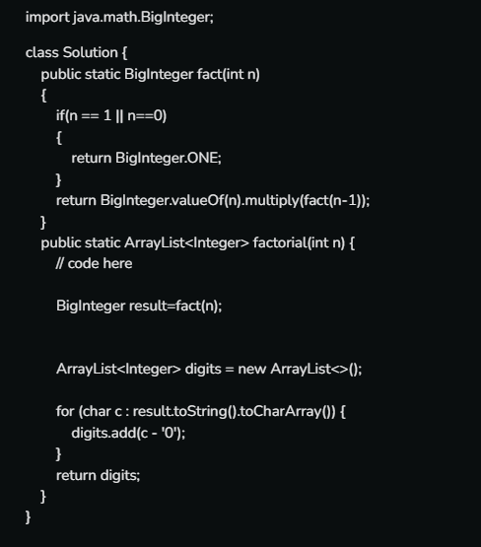

21.Maximum Product subarray

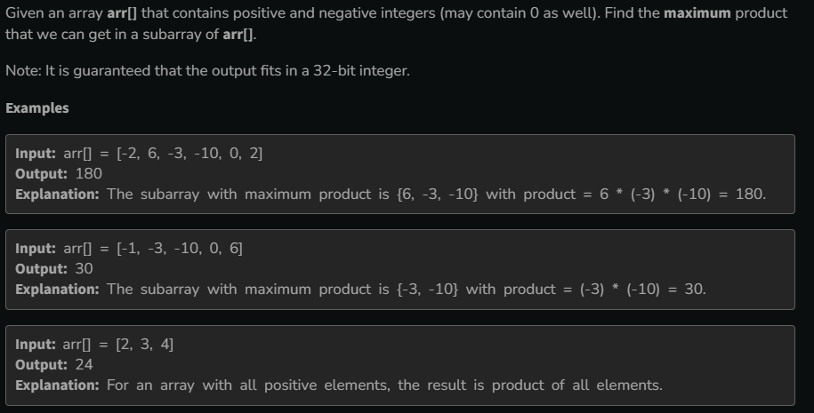

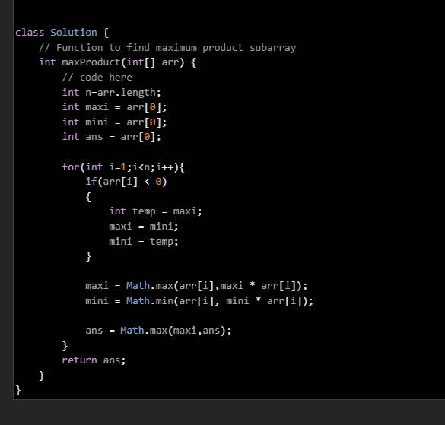

22.Longest Consecutive subsequence

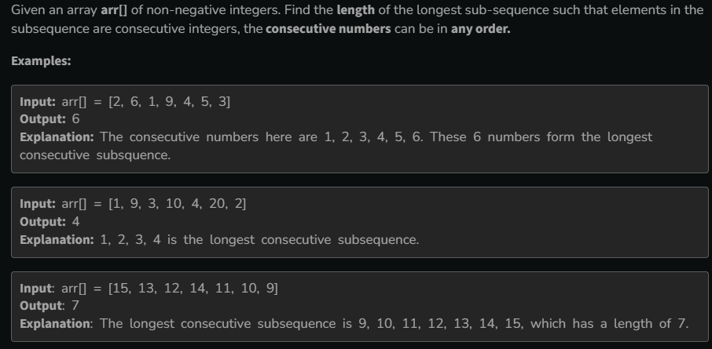

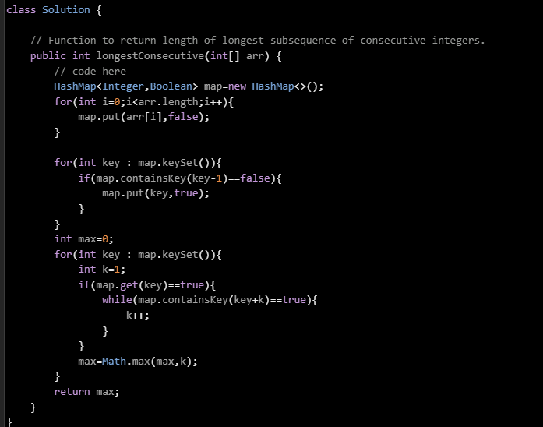

23.Majority Element II

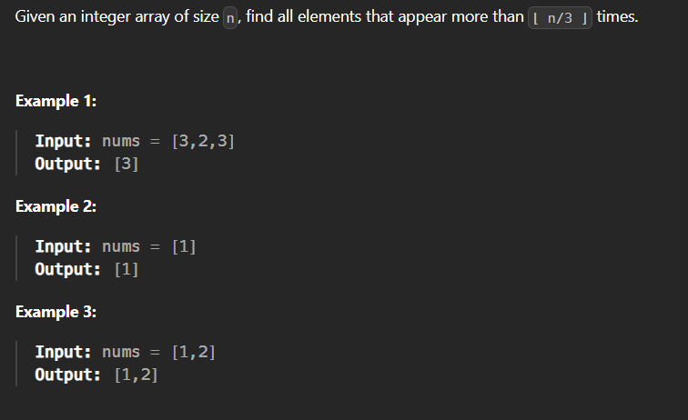

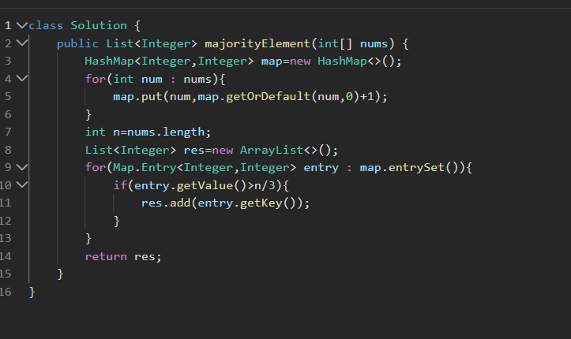

24.Best time to sell and buy stock III

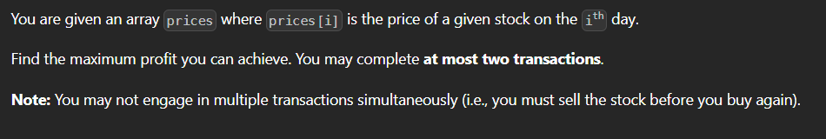

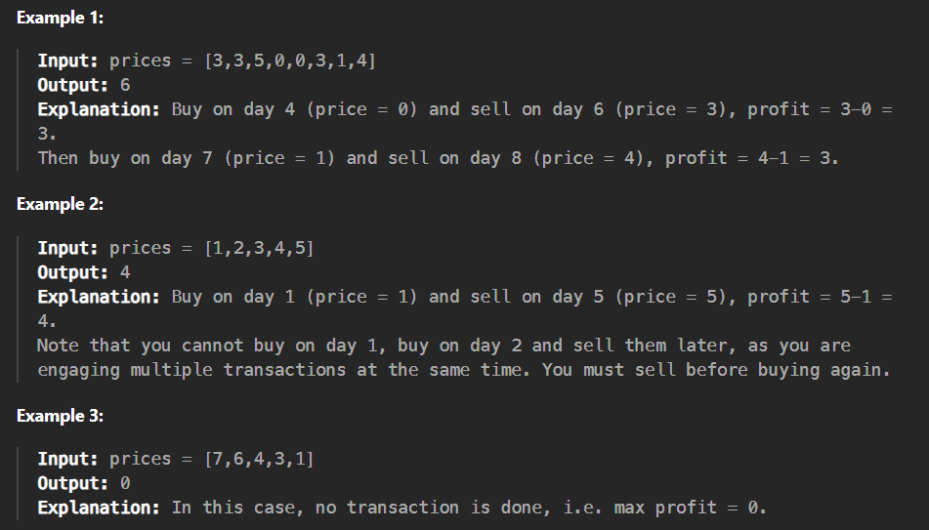

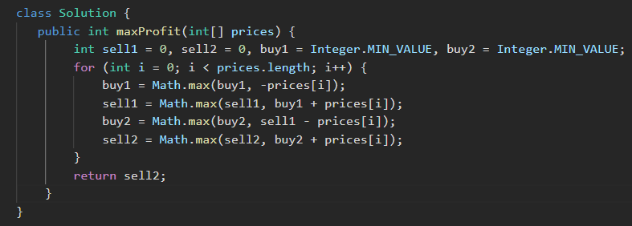

25.Trapping Rain Water



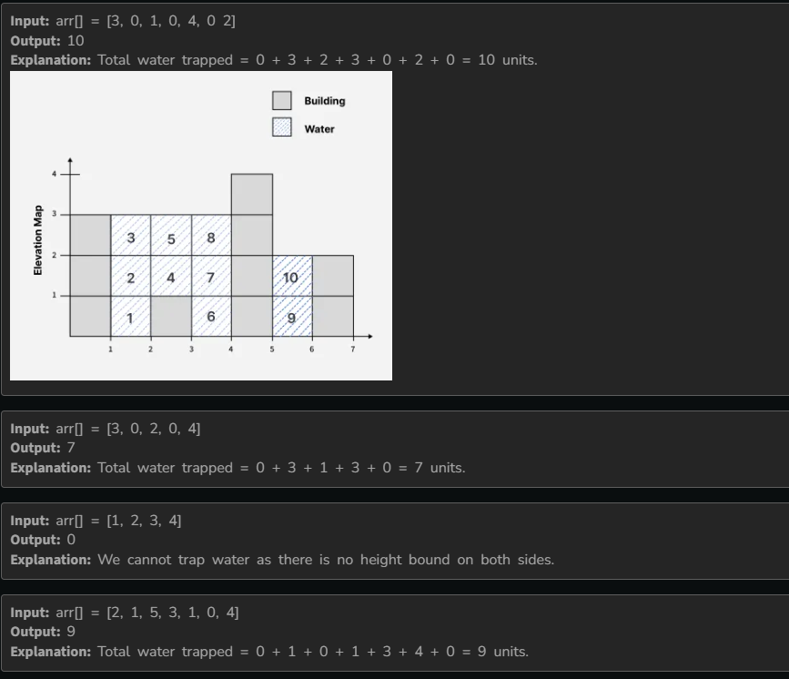

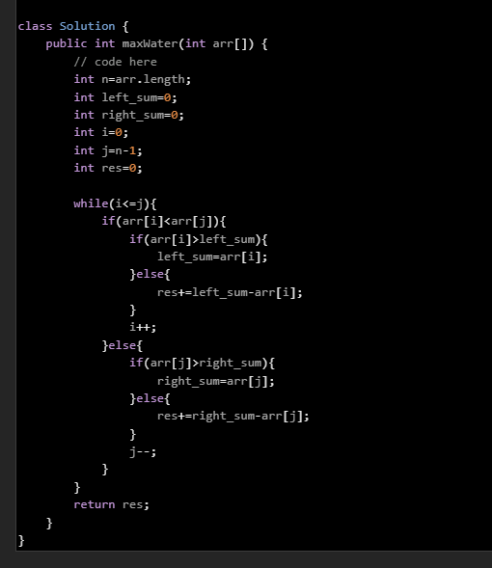

26.Chocolate distribution problem

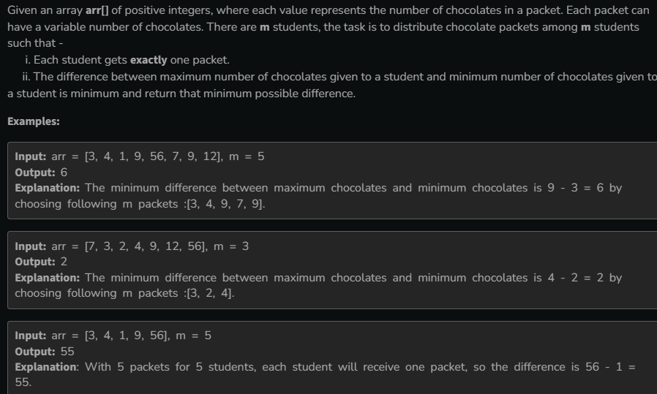

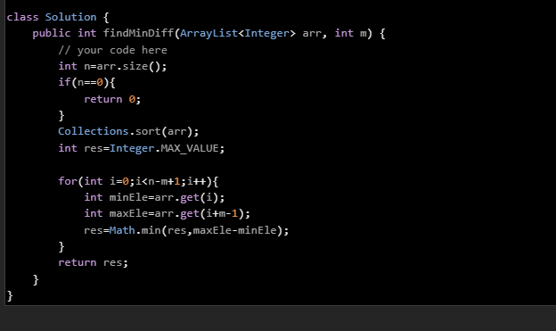

27.Minimum size subarray sum

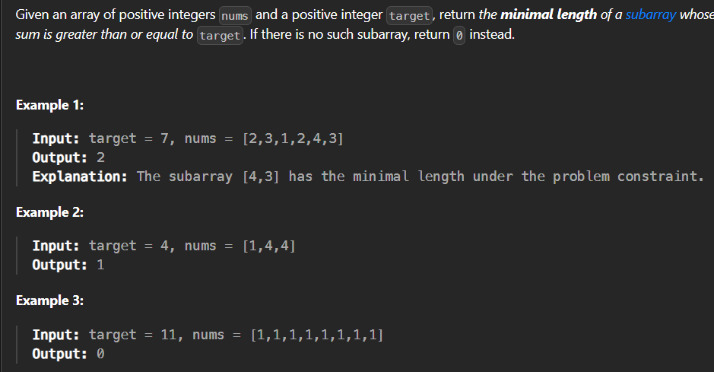

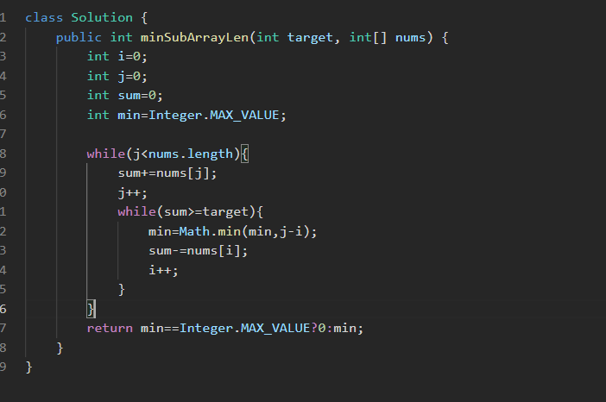

28.Median of two sorted array

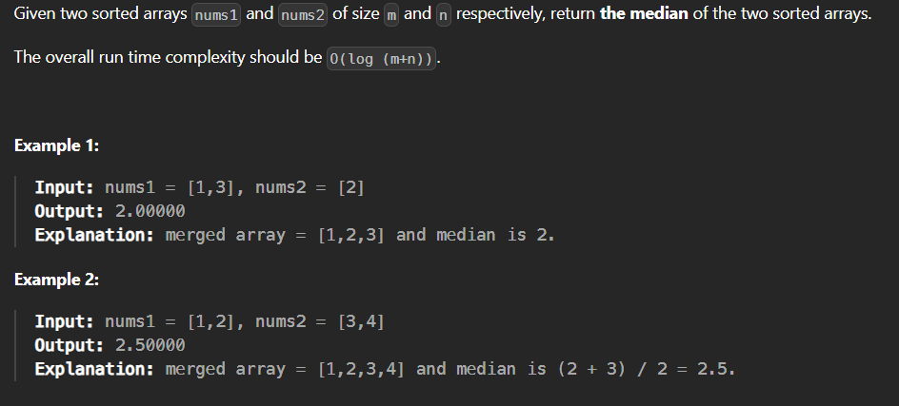

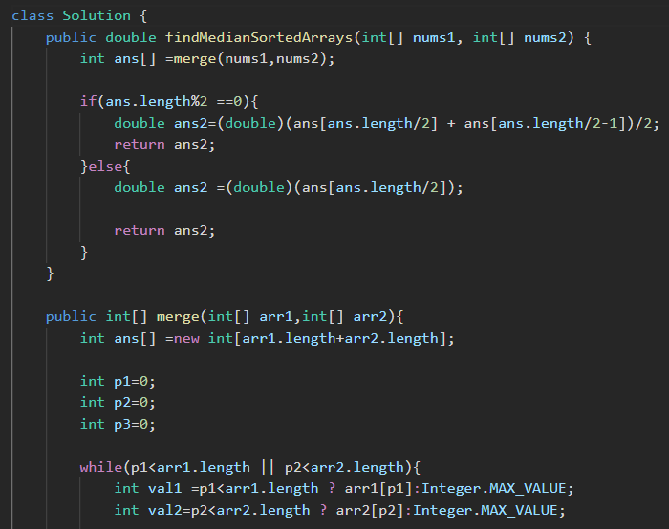

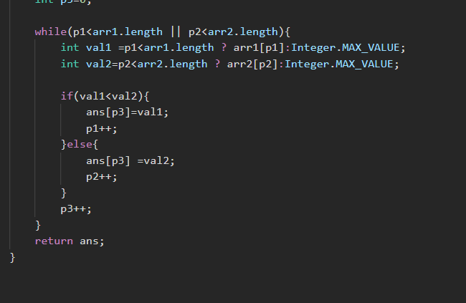

29.Alternate Positive Negative

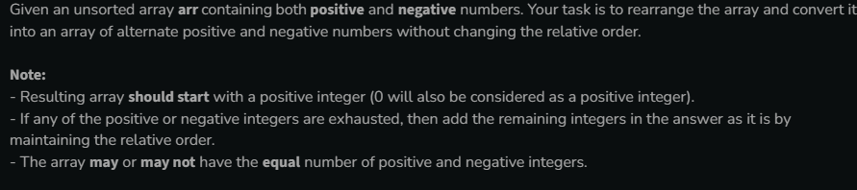

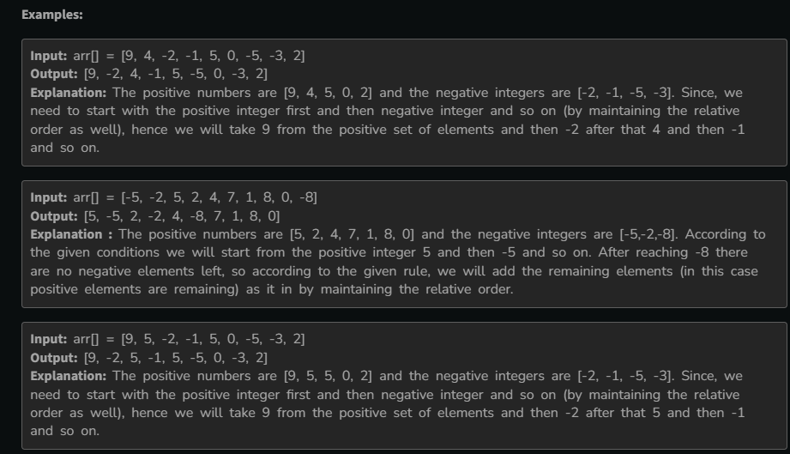

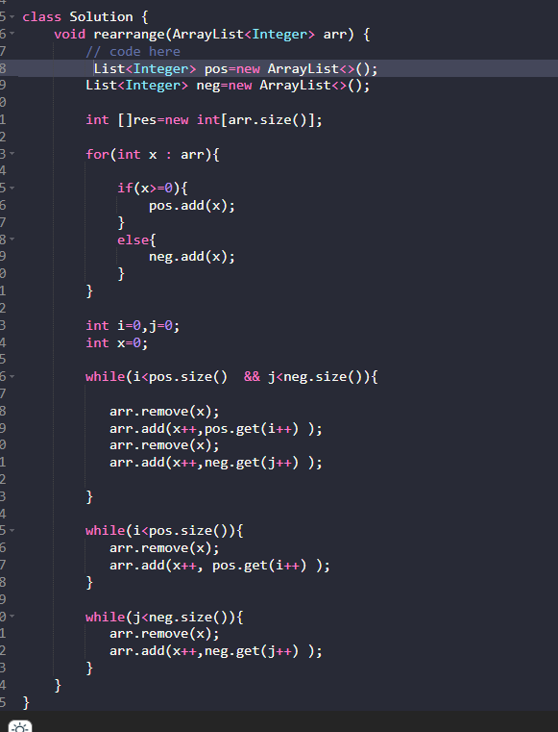

30.Three way partitioning

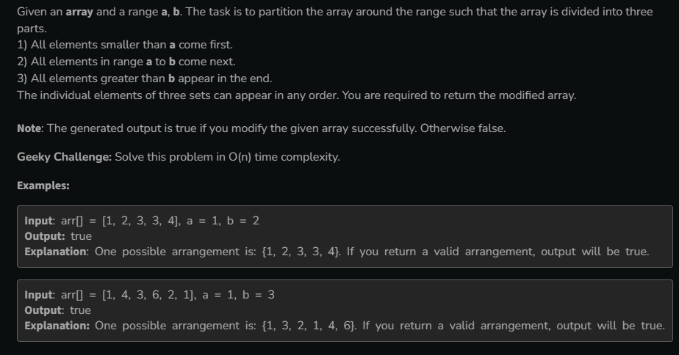

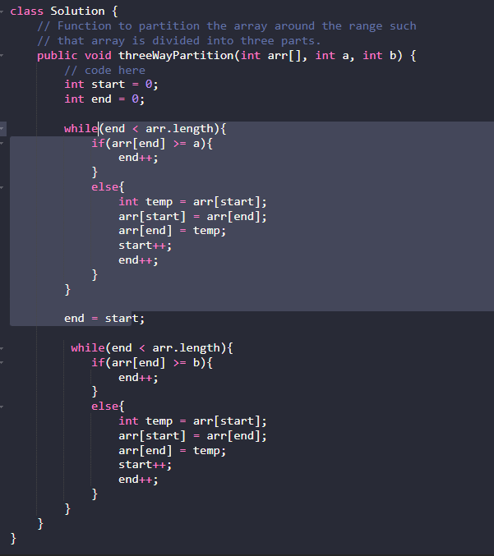

31.Minimum swaps and k Together

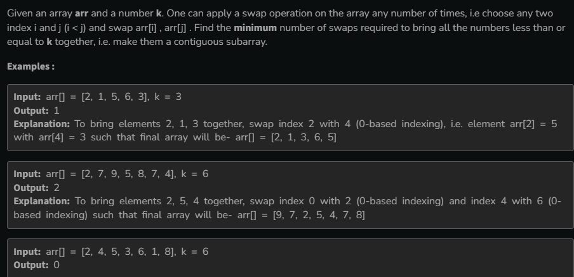

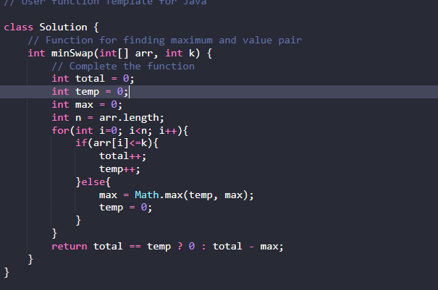

32.Minimum Number of moves to make Palindrome

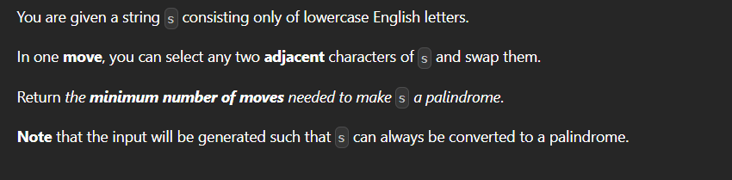

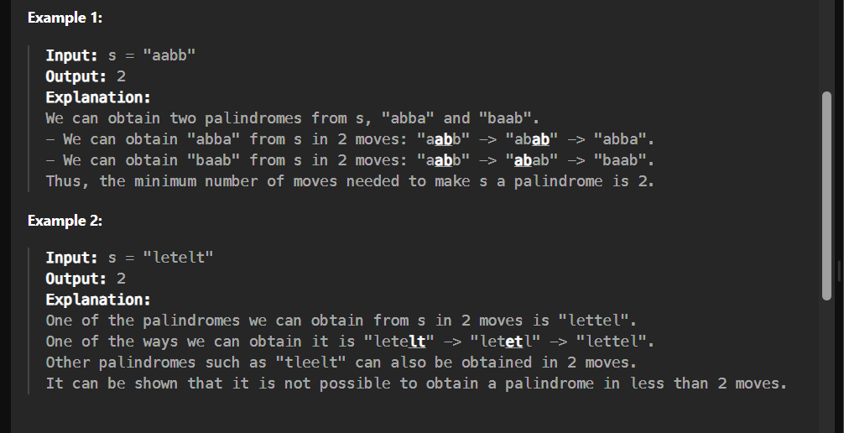

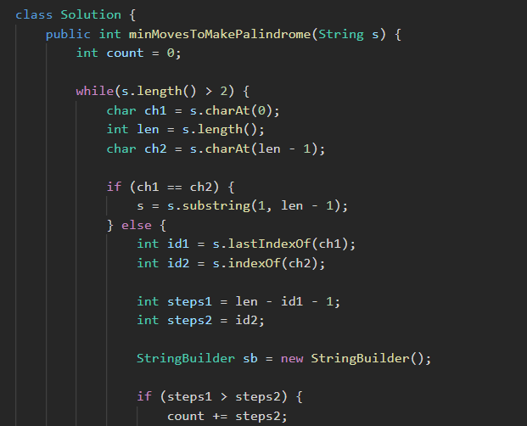

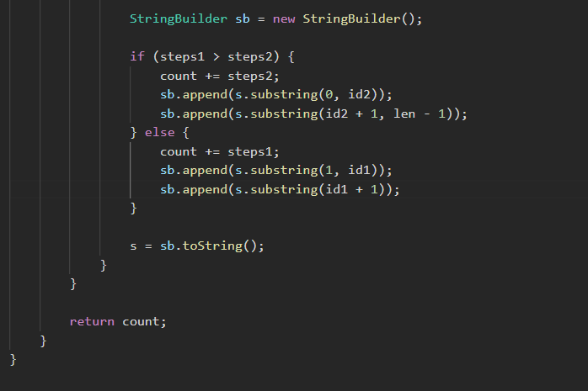

33.Median of 2 sorted Array of same size

